Graduate Entrepreneurial Learning

A longitudinal study of the development of nascent graduate entrepreneurs

1.0 Project Aim

The aim of the research is to provide an insight into the ways that nascent graduate entrepreneurs develop. The research will investigate three inter-related themes – the development of their entrepreneurial capabilities, the progress of their entrepreneurial career, and the success of their business activities.

A practical aim is to be able to recommend ways that such graduates can be helped to achieve their entrepreneurial ambitions.

The research will probably focus mainly on graduates from the creative sector.

2.0 Project Justification

Both nationally and regionally there has been a strong interest in encouraging students to set up enterprises soon after graduating. Indeed the National Council for Graduate Entrepreneurship (NCGE) was set up in 2004 specifically to do this. This research proposal springs directly from work done by myself for the NCGE, in collaboration with John Blenkinsopp in 2007 (Blenkinsopp, J., Fuller, E., Hanage, R., et al., 2007)

The policy interest has broadened into encouraging graduates to be more entrepreneurial not just in business start-up but also, for instance, in developing a social enterprise, or becoming an intrapreneur in an existing organisation of any type. These wider outcomes are all expected to have a positive influence on the UK economy.

Graduates from the creative subjects are of especial interest as they are often less entrepreneurial by nature, but are entering sectors in which a conventional employment-based career is hard to follow.

‘Students lack a clear understanding of how [entrepreneurship] relates to their own practices and future working lives’ (NESTA 2007)

Although a great deal of work has been done on entrepreneurship and, to a lesser degree, on graduate entrepreneurship, there seems to be a dearth of longitudinal studies. As I have access to appropriate students, and no pressure to complete the project quickly, I can carry out research which may be able to cast new light on how graduates develop and learn as entrepreneurs.

3.0 Study Context

a) Economic. The national and regional economic context has already been referred to, above.

b) University. Within Universities there is an increasing awareness of the need to make enterprise education more widely available and to prepare graduates for a more flexible and entrepreneurial career. This manifests itself in intra-curricular modules, a range of extra-curricular activities, and increasing post-graduate support through, for example, business incubators.

The participants in the proposed research will probably be mainly involved in extra-curricular and post-graduate activities as these are well represented in the University of Teesside, where the initial research will be carried out.

c) Academic. There are a number of academics who are actively pursuing research into entrepreneurial learning. Their focus is shifting from looking at fixed personality traits, economic views of the entrepreneur, and cognitive approaches to understanding that people develop their entrepreneurial behaviour by social learning. This includes sense-making, sense-giving, negotiation with other stakeholders, and immersion in existing enterprises.

The participants in the research will be of particular interest as some of them may lack the conventionally expected entrepreneurial personality traits, and may therefore be developing their entrepreneurial skills from a low base. Other research seems to mainly look at existing successful entrepreneurs.

d) Researcher. I work extensively with students and graduates in the University by running business start-up courses, providing one-to-one support, and helping them prepare business plans. I also start and run small businesses myself so am already embedded within the small business and business support sectors.

This puts me in a strong position to carry out qualitative research from the ‘inside’, and has an influence on the methodologies to be used.

e) Personal. The personal context is also important. Embarking on the PhD is a personal challenge which should broaden and deepen my understanding of entrepreneurship, increase my business credibility, and extend my active career.

4.0 Theoretical Underpinning

a) A Typology of Graduate Entrepreneurs
Blenkinsopp (Blenkinsopp, J., Fuller, E., Hanage, R., et al. ,2007) has suggested a typology of graduate entrepreneurs from the ‘natural entrepreneur’ through to the ‘life-style entrepreneur’. Each of the three types appears to have very different characteristics, which are likely to influence their business success, their entrepreneurial learning and their career choices. In addition each type may have different aspirations for the timing of business start-up.

(see Fig 1, below)

 | Natural Entrepreneur | Reluctant Entrepreneur | Life-style Entrepreneur
Start-up on graduation
Start-up after taking stock
Start-up later in their career
Fig 1: The Blenkinsopp Typology of Graduate Entrepreneurs.

The membership of the cohorts will be chosen to try to ensure that each type is well represented so that the research can be used to validate the typology in the three following areas.

The typology will be tested early in the research, and may be used as either as theoretical framework or else as a tool to structure the sample of graduates investigated.

b) Business Start-up. There is a long-established base of literature on business start-up, survival and growth, starting with seminal work in the 1980’s by Allan Gibb at Durham University, and followed by numerous colleagues who developed his ideas further. More recently there is a shift in conceptual thinking from, for instance, environmental scanning to interpretation of information and further to sense-making and sense-giving. This appears to mirror the changing views of entrepreneurial learning, and will be investigated more in the literature review.

c) Entrepreneurial Learning. The literature on entrepreneurial learning also seems to be still evolving rapidly as the personality trait, economic and cognitive approaches are replaced by an understanding that it is more of a social learning process.

At this early stage in the project I have been greatly influenced by the work of David Rae, currently at the University of Lincoln. His book (Rae, 2007) proposes a 13-part social learning model of entrepreneurial learning which includes three major themes:

- Personal and social emergence: learning to ‘become an entrepreneur’
- Contextual learning: learning from immersion in a sector or an organisation.
- Negotiated enterprise: learning from starting a new venture.

See Fig 2, below.
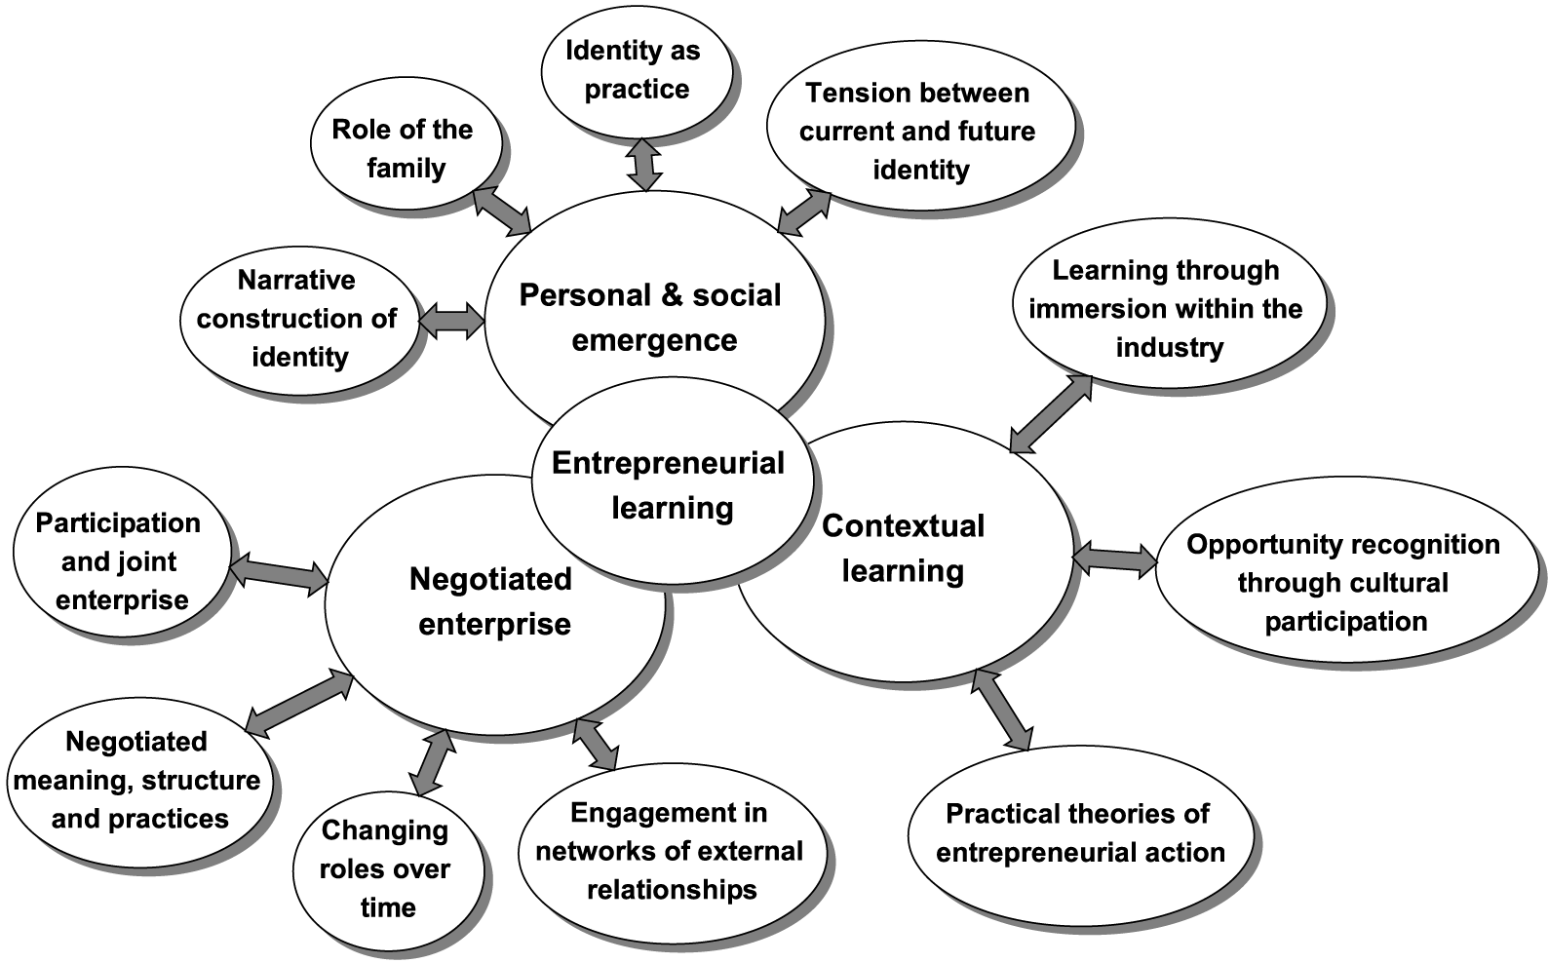

Fig 2: Triadic Model of Entrepreneurial Learning (Rae 2007)

d) Career Development
A graduate starting a business is experimenting with one possible career option. Depending on their position in the Blenkinsopp typology they may have several other options. Their attitude to the business, their propensity to learn, and their commitment to this particular career option will be explored in relation to the typology. Relevant theories of graduate career development will be investigated further in the literature review.

5.0 Methodology

The main research method will be the narrative life-history approach – as narratives are ‘particularly useful in developing social histories of identity and development’ (Easterby-Smith et al 2008). This approach will be qualitative and illuminative, rather than generalisable, but will be supplemented by some quantitative data-gathering.

The research on the participants will be done in three stages:
- a retrospective study of their prior business experience and learning processes
- a snapshot of their current skills, experience, aspirations and venture creation status
- longitudinal tracking of their responses to events over the following three years and the effect of these on their learning, their business activities and their career aspirations.

The methodology will be different for each of the three stages. Some quantitative data will be collected, eg demographics, business assessment, personality traits, and current behaviours. However the main thrust of the research will be on narrative qualitative data – developing the stories of how each person develops as an entrepreneur.

I expect to be actively working with many of the participants so there will be elements of action research and possibly collaborative group based research.

There will be two types of cohort.

The first will be from students who have expressed an interest in business start-up. It can be expected that their careers will diverge significantly, and that many will not attempt business start-up during the period of the study. The divergence will be explored in relation to the Blenkinsopp typology and the Rae model. There will be at least two of these cohorts, a year apart.

The second type of cohort, of which there will be one, will consist of existing graduate entrepreneurs. In this case the retrospective study will cover a longer period of business activity, including actual business start-up. It will be instructive to compare the two cohorts in the light of attribution theory and event recall.

For each cohort the methodology will be:

Stage 1: The retrospective study will be mainly based on in-depth interviews, supplemented by a questionnaire to collect quantitative and demographic data.

Stage 2: The snapshot of their current situation will be mainly based on questionnaires and existing assessment tools, supplemented by interview.

At this stage the participants will each be located in the Blenkinsopp typology

Stage 3: Longitudinal tracking will be the core of the research, and will be mainly based on in-depth interviews, probably every six months. Questionnaires and other assessment tools will also be used to provide quantitative tracking data.

This stage will be modelled on the process used by Rae in tracking the development of three existing entrepreneurs in the creative sector over a two year period:
“The methodology used is social constructionist, narrative, and interpretive. It aims to explore the entrepreneurial learning process in the “lifeworld” of the entrepreneur, by gaining access to their actions, environment, interactions with others, and, perhaps most important, their narrative accounts of their personal and business venturing, and their learning.” (Rae 2004a)
If possible all interviews will be videoed in order to facilitate analysis of both verbal content and non-verbal information.

The data analysis strategy will probably be a mix of:
a) content analysis, for instance to look for evidence to support the Rae model, and explore its applicability to each ‘cell’ in the Blenkinsopp typology
b) grounded analysis to look for new insights
c) simple quantitative analysis, for instance, if numeric data for each ‘cell’ has been collected.

Both the literature research and the primary research will be project managed and analysed using NVivo.

If a robust and reproducible methodology is developed, it may be possible to apply it, partially or fully, to students in other situations or countries.

6.0 Project Plan

The outline project plan is shown below (Fig 3).
Black squares indicate high levels of activity
Grey squares indicate reduced levels.

 | 2009 | 2010 | 2011 | 2012 | 2013 | 2014
Literature research
Test typology
Cohort 1 (new grads)
Cohort2 (in business)
Cohort 3 (new grads)
Data analysis
Write up
Fig3: Research Plan

7.0 References/Bibliography

The research will be rooted in the fields of entrepreneurship, enterprise creation and entrepreneurial learning. It will also take in material from the fields of career development, enterprise education, and entrepreneurship in economy.

Ball, L. (2003). Future Directions for Employability Research in the Creative Industries. Brighton, Design Council and LTSN: 47.
Baruch, Y. (2004). Managing Careers: Theory and Practice. Harlow, Pearson Education.
Blenkinsopp, J., Fuller, E., Hanage, R., et al. (2007). "Advising entrepreneurial students" Retrieved December, 2008, from http://www.ncge.com/communities/careers/reference/detail/970/2.
Bradley, D. E., and Roberts, J. A. (2004). "Self-employment and Job Satisfaction : Investigating the Role of Self-efficacy, Depression and Seniority." Journal of Small Business Management 42(1): 37-58.
Carter, S., and Jones-Evans, D. (2006). Enterprise and Small Business. Harlow, Pearson Education.
Charmaz, K. (2006). Constructing Grounded Theory. London, SAGE Publications.
Gregorio, S. (2000). Using NVivo for your Literature Review. Strategies in Qualitative Research. London: 12.
Dweck, C., and Aldous, P. (2008). Free Your Mind and Watch It Grow. New Scientist. London: 44-45.
Easterby-Smith, M., Thorpe, R., and Jackson, P. (2008). Management Research. London, SAGE.
Gibb, A. A. (2008). Notes on Developing Entrepreneurial Graduates. Launch of 'Developing Entrepreneurial Graduates'. London, NESTA: 2.
Gossen, R. J. (2004). "Entrepreneurship and the Meaning of Life." JBIB: 21-74.
Greene, F. J., and Saridakis, G (2007). Understanding the Factors Influencing Graduate Entrepreneurship. Warwick, Warwick Business School: 69.
Hannon, P., et al. (2004). Making the Journey from Student to Entrepreneur. Birmingham, University of Central England: 85.
Hart, C. (2001). Doing a Literature Search. London, Sage Publications.
Herrmann, K., and Ternouth, P. (2008). Developing Entrepreneurial Graduates. CIHE. London, CIHE.
Herrmann, K. (2008). Developing Entrepreneurial Graduates - Putting Entrepreneurship at the Centre of Higher Education. London CIHE, NESTA, NCGE: 36.
Jones, A., et al (2008). How Can Cities Thrive in the Changing Economy? London, The Work Foundation: 99.
Korunka, C., et al (2003). "The Entrepreneurial Personality in the Context of Resources, Environment, and the Start-up Process - A Configurational Approach." Entrepreneurship Theory and Practice 2003(Fall): 23-42.
Lofland, J., Snow, D., Anderson, L., and Lofland, L. H. (2006). Analyzing Social Settings. USA, Wadsworth/Thompson Learning.
Million+ (2007). Creative Futures - Building the Creative Economy through Universities. Million+. London, Million+.
Mullins, J. W. (2006). New Business Road Test. Harlow, Pearson Education.
NCGE (2007). Enterprise and Entrepreneurship in Higher Education. Birmingham, NCGE: 7.
NESTA (2007). Entrepreneurship Education for the Creative Sector. NESTA. London, NESTA.
NESTA (2008). Level Up - Building a Stronger Games Sector. NESTA. London, NESTA.
Parker, S. C. (2006). "Learning about the unknown: How fast do entrepreneurs adjust their beliefs?" Journal of Business Venturing 21: 1-26.
Phillips, E., and Pugh, D.S. (2005). How to Get a PhD. Maidenhead, OU Press.
Rae, D. (1999). Understanding Entrepreneurial Learning: a Question of How? 3rd Enterprise and Learning Conference. Paisley.
Rae, D., and Carswell, M (2000). "Towards a Conceptual Understanding of Entrepreneurial Learning." Journal of Small Business and Enterprise Development 8(2): 9.
Rae, D. (2004a). "Entrepreneurial Learning: a Practical Model from the Creative Industries." Education and Training 46(8-9): 492-500.
Rae, D. (2004b). "Practical Theories from Entrepreneurs Stories: Discursive Approaches to Entrepreneurial Learning." Journal of Small Business and Enterprise Development 11(2): 7.
Rae, D. (2007). Entrepreneurship: from opportunity to action. New York, Palgrave MacMillan.
Rea, D., and Woodier, N. (2006). Graduate Career Choices and Entrepreneurship. Derby, Centre for Entrepreneurial Management: 60.
Rogoff, E. J., Myung-Soo, L., and Dong Churl, S. (2004). "Who Done It? Attributions by Entrepreneurs and Experts of the Factors that Cause and Impede Small Business Success." Journal of Small Business Management 42(4): 364-376.
Rowe, D. (2008). Ask Better Questions. New Scientist. London: 18.
Sharp, D. (2004). Creative Industries Roadmap. Middlesbrough, University of Teesside: 60.
Shepherd, D. A. (2004). "Educating Entrepreneurship Students About Emotion and Learning from Failure." Academy of Management Learning and Education 3(3): 274-287.
Steiner, R. (1998). My First Break. London, New International.
Wayman, M., and Brown, B. (2007). Creating Entrepreneurship: Entrepreneurship Education for the Creative Industries. London, NESTA: 124.
Whickams, P. (2004). Strategic Entrepreneurship. Harlow, Pearson Education.
Williams, S. (2004). Small Business Guide. London, Financial Times.
Young, J. E., and Sexton, D. L. (2003). "What Makes Entrepreneurs Learn, and How Do They Do It?" Journal of Entrepreneurship 12(2): 155-182.

Richard Hanage
18 Feb 2009

